
Holy Cross College

Semester 2 Examination 2013

Question/Answer Booklet

Year 10 Science
Please place your student identification label in this box
(Extension)

Chemistry

Student Name
Student’s Teacher

Time allowed for this paper

Reading time before commencing work: 10 minutes
Working time for paper: 110 minutes

Materials required/recommended for this paper

To be provided by the supervisor

This Question/Answer Booklet
Data Sheet

To be provided by the candidate

Standard items: pens, pencils, eraser, correction fluid, ruler, highlighters.
Special items: non-programmable calculators satisfying the conditions set by the School Curriculum and Standards Authority for this course.

Important note to candidates

No other items may be taken into the examination room. It is your responsibility to ensure that you do not have any unauthorised notes or other items of a non-personal nature in the examination room. If you have any unauthorised material with you, hand it to the supervisor before reading any further.
Structure of this paper

Section | Number of questions available | Number of questions to be answered | Suggested working time  (minutes) | Marks available | Percentage of exam
Section One:  Multiple Choice | 50 | 50 | 40 | 50 | 32
Section Two:  Short Answer | 17 | 17 | 55 | 88 | 56
Section Three:  Comprehension | 9 | 9 | 15 | 18 | 12
 |  |  |  | 156 | 100

Instructions to candidates

1. The rules for the conduct of examinations at Holy Cross College are detailed in the College
Examination Policy. Sitting this examination implies that you agree to abide by these rules.

2. Write your answers in this Question/Answer Booklet.

3. Working or reasoning should be clearly shown when calculating or estimating answers.

4. You must be careful to confine your responses to the specific questions asked and to follow
any instructions that are specific to a particular question.

5. Spare pages are included at the end of this booklet. They can be used for planning your
responses and/or as additional space if required to continue an answer.

• Planning: If you use the spare pages for planning, indicate this clearly at the top of the
page.
• Continuing an answer: If you need to use the space to continue an answer, indicate in
the original answer space where the answer is continued, i.e. give the page number.
Fill in the number of the question(s) that you are continuing to answer at the top of the
page.

Achievement Standards

The atomic structure and properties of elements are used to organise them in the Periodic Table.

Different types of chemical reactions are used to produce a range of products and can occur at different rates.
SECTION 1 MULTIPLE CHOICE (50 marks)

Choose the best answer for each question in the Multiple Choice Question booklet.

Mark your selection with a cross.

1 | (a) | (b) | (c) | (d) |  | 31 | (a) | (b) | (c) | (d)
2 | (a) | (b) | (c) | (d) |  | 32 | (a) | (b) | (c) | (d)
3 | (a) | (b) | (c) | (d) |  | 33 | (a) | (b) | (c) | (d)
4 | (a) | (b) | (c) | (d) |  | 34 | (a) | (b) | (c) | (d)
5 | (a) | (b) | (c) | (d) |  | 35 | (a) | (b) | (c) | (d)
6 | (a) | (b) | (c) | (d) |  | 36 | (a) | (b) | (c) | (d)
7 | (a) | (b) | (c) | (d) |  | 37 | (a) | (b) | (c) | (d)
8 | (a) | (b) | (c) | (d) |  | 38 | (a) | (b) | (c) | (d)
9 | (a) | (b) | (c) | (d) |  | 39 | (a) | (b) | (c) | (d)
10 | (a) | (b) | (c) | (d) |  | 40 | (a) | (b) | (c) | (d)
11 | (a) | (b) | (c) | (d) |  | 41 | (a) | (b) | (c) | (d)
12 | (a) | (b) | (c) | (d) |  | 42 | (a) | (b) | (c) | (d)
13 | (a) | (b) | (c) | (d) |  | 43 | (a) | (b) | (c) | (d)
14 | (a) | (b) | (c) | (d) |  | 44 | (a) | (b) | (c) | (d)
15 | (a) | (b) | (c) | (d) |  | 45 | (a) | (b) | (c) | (d)
16 | (a) | (b) | (c) | (d) |  | 46 | (a) | (b) | (c) | (d)
17 | (a) | (b) | (c) | (d) |  | 47 | (a) | (b) | (c) | (d)
18 | (a) | (b) | (c) | (d) |  | 48 | (a) | (b) | (c) | (d)
19 | (a) | (b) | (c) | (d) |  | 49 | (a) | (b) | (c) | (d)
20 | (a) | (b) | (c) | (d) |  | 50 | (a) | (b) | (c) | (d)
21 | (a) | (b) | (c) | (d)
22 | (a) | (b) | (c) | (d)
23 | (a) | (b) | (c) | (d)
24 | (a) | (b) | (c) | (d)
25 | (a) | (b) | (c) | (d)
26 | (a) | (b) | (c) | (d)
27 | (a) | (b) | (c) | (d)
28 | (a) | (b) | (c) | (d)
29 | (a) | (b) | (c) | (d)
30 | (a) | (b) | (c) | (d)

SECTION 2 SHORT ANSWER (88 marks)

Attempt all questions. Write your answers in the spaces provided.

1. Classify the following elements as alkali metals, transition metals, metalloid (semi-metals),
halogens or noble (inert) gases. Use the periodic table on the data sheet provided.

K Ge He Cu Fr Cl Ag Ar

Alkali Metal | Transition Metal | Metalloid  (Semi-Metal) | Halogen | Noble (Inert) Gas

(4 marks)

2. Complete the following table showing the name of the element and its constituent particles.

ELEMENT | PROTONS | NEUTRONS | ELECTRONS
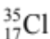
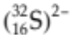
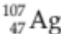

(4 marks)

3. An aluminium atom (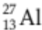) has the ability to form the Al³⁺ ion. It can then form ionic compounds
with other ions such as Cl¹⁻.

(a) Draw a diagram to show the electron configuration in the aluminium atom.

(2 marks)

(b) Explain what happens in order for the aluminium atom to become the aluminium ion Al³⁺.

(2 marks)
(c) Why is the Al³⁺ ion so stable?

(2 marks)

(d) Explain how the "ionic bond" arises between the Al³⁺ ion and the Cl¹⁻ ion. A simple labelled
diagram may help your explanation.

(2 marks)

4. Write the chemical formula for each of the following compounds.
NAME | FORMULA
potassium nitrate
magnesium phosphate
aluminium sulphate
phosphorus tribromide
iron (III) iodide
barium acetate
disulphur tetraiodide

(7 marks)

5. Classify the following substances into the appropriate column in the table below, according to the
major type of bonding between particles.

zinc sulphate H₂ SiO₂ P₂O₅ water ammonium carbonate H₂SO₄ barium
METAL | IONIC | COVALENT

(4 marks)

6. Draw the electron dot diagrams for the following species.

(a) Cl₂O (b) Al₂O₃

(c) HCN (d) Na₂S

(6 marks)

7. NH₃ (ammonia) is a covalent molecular substance that is a gas at room temperature.

(a) Draw the electron dot diagram for NH₃, and circle one bonding pair of electrons.

(2 marks)

(b) Refer to the diagram you have drawn to help explain and define what is a covalent bond.

(2 marks)

8. Balance the following equations.

(a) Al₂(CO₃)₃ + HCl  AlCl₃ + H₂O + CO₂

(b) C₃H₈ + O₂  CO₂ + H₂O

(c) NaOH + Fe(NO₃)₂  Fe(OH)₂ + NaNO₃

(6 marks)

9. Classify the following substances as acid, base, salt or other.

H₂SO₄ CaO NH₃ MgCO₃ CH₃COOH H₂S Al(OH)₃ P₂O₅

ACID | BASE | SALT | OTHER

(4 marks)

10. Write a balanced molecular and ionic equation for each of the following reactions involving acids.
Use subscripts to show the phase of the species present.

(a) Solid aluminium carbonate added to nitric acid.

Molecular:

Ionic:

(3 marks)

(b) Solid zinc added to acetic acid.

Molecular:

Ionic:

(3 marks)
11. Complete the following table showing the acid and base characteristics of some common substances.
In the final column, indicate whether the acid or base is strong or weak.

SUBSTANCE | UNIVERSAL INDICATOR  COLOUR | ESTIMATED pH | ACID / BASE/ NEUTRAL
human urine |  |  | very weak acid
grape juice |  | 4
household ammonia | light blue

(3 marks)

12. Write fully balanced equations for the following.

(a) calcium hydroxide + phosphoric acid (H₃PO₄)  calcium phosphate + water

(b) hexane (C₆H₁₄) + oxygen  carbon dioxide + water

(4 marks)

13. Use the table of solubilities to determine whether a reaction occurs when the following solutions are
mixed. Where a reaction occurs, write a balanced ionic equation. Write "no reaction" if
appropriate.

(a) Aluminium nitrate solution + sodium sulphate solution.

(b) Barium nitrate solution + potassium hydroxide solution.

(c) Magnesium chloride solution + sodium phosphate solution.

(5 marks)
14. Calculate the formula or molecular mass of the following compounds.

(3 marks)
COMPOUND | FORMULA/MOLECULAR MASS (gmol⁻¹)
Ba(NO₃)₂
H₂SO₄
Pb₃(PO₄)₂
15. The overall equation for a lead-acid battery is given below. Use it to determine the mole ratios given.

Pb _{(s)} + PbO₂ _{(s)} + 4 H¹⁺ _{(aq)} + 2 SO₄²⁻ _{(aq)}  2 PbSO₄ _{(s)} + 2 H₂O _{(l)}

n(H¹⁺) = x n(PbSO₄) n(PbO₂) = x n(SO₄²⁻)

n(Pb) = x n(H¹⁺) n(H₂O) = x n(Pb)

(4 marks)
THIS PAGE HAS BEEN DELIBERATELY LEFT BLANK.

16. A 27.3 g sample of potassium phosphate is reacted with excess calcium chloride. The reaction is
represented by the equation below.

2 K₃PO_{4 (s)} + 3 CaCl_{2 (aq)}  Ca₃(PO₄)_{2 (s)} + 6 KCl _{(aq)}

(a) How many moles of potassium phosphate are reacted?

(2 marks)

(b) What mass of potassium chloride is produced?

(3 marks)
(c) Determine the mass of calcium chloride used up in the reaction.

(3 marks)
17. Octane (C₈H₁₈) is a major component of petrol. When petrol is burned in a car engine, the octane reacts as follows.

2 C₈H_{18(l)} + 25 O_{2(g)}  16 CO_{2(g)} + 18 H₂O_{(g)}

1.00 L of petrol has a mass of 0.850 kg. A car uses 12.0 L of petrol on a trip to the country.

(a) What mass of petrol (octane) is used during the trip?

(1 mark)

(b) Determine the mass of O₂ consumed during the trip.

(4 marks)

(c) Calculate the mass of CO₂ produced.

(3 marks)

SECTION 3 COMPREHENSION (18 marks)

Read the article and then answer the questions that follow. Write your answers in the spaces provided.

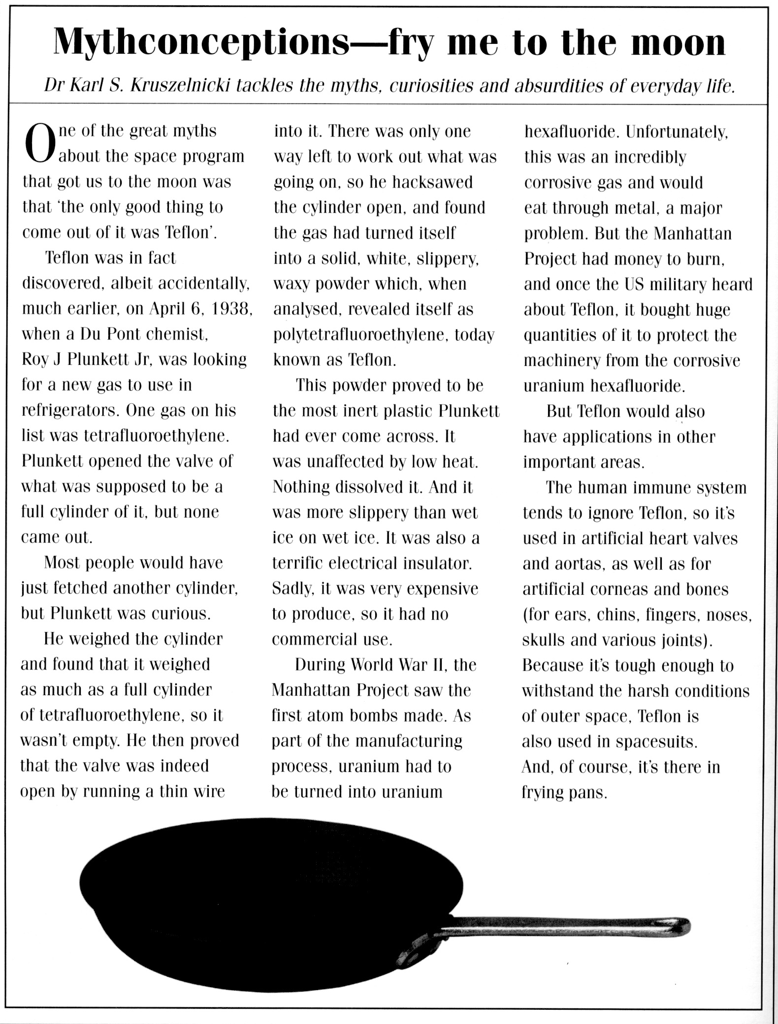
1. When was Teflon discovered and by whom?

(2 marks)

2. What is the correct chemical name of Teflon?

(1 mark)
3. Describe what Teflon looks like.

(2 marks)

4. What properties make Teflon an extremely useful material?

(2 marks)

5. Teflon is said to be inert - what does this mean?

(1 mark)

6. What research was the inventor doing when he discovered Teflon?

(1 mark)

7. What stopped Teflon from being commercially produced in the early days?

(1 mark)

8. Is Teflon a metal or a plastic? Give one piece of evidence.

(2 marks)
9. Complete the following table about the uses of Teflon.

LOCATION | USE | PROPERTY RELATED TO USES
Body
Space
Kitchen

(6 marks)

END OF EXAMINATION

THIS PAGE HAS BEEN DELIBERATELY LEFT BLANK.

